Inplace upgrade of Windows server 2012R2 to 2016

## Server name : USE-PRD-SAP2016

Template size : Standard D2ads v5 (2 vcpus, 8 GiB memory)

Domain Joined :Yes

WE have created below win 2012R2 VM and performed all the On boarding task

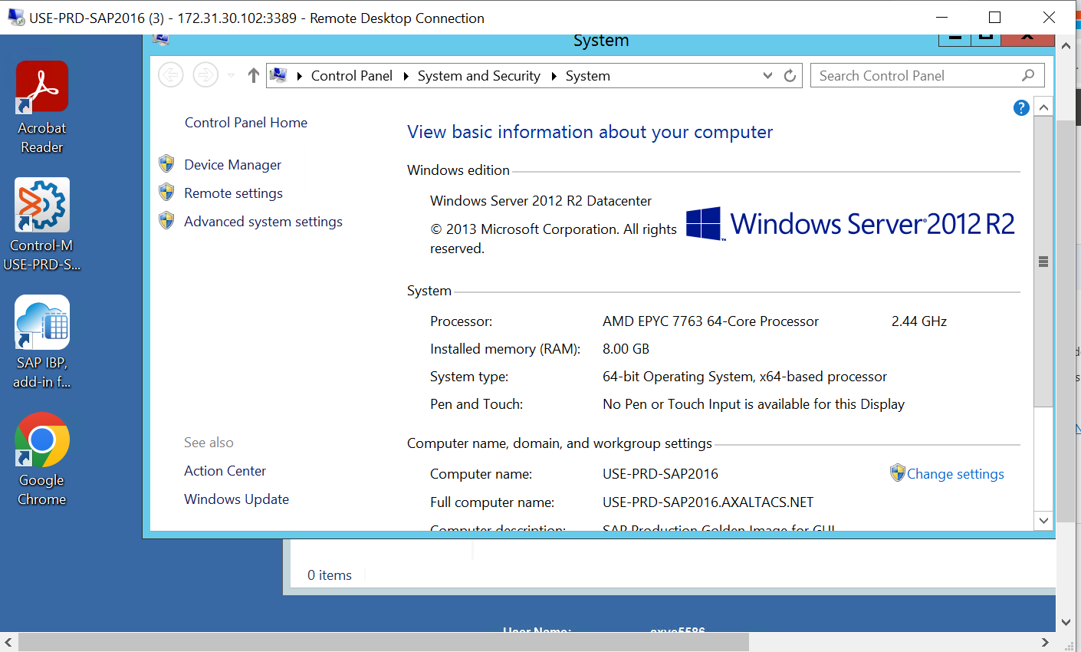

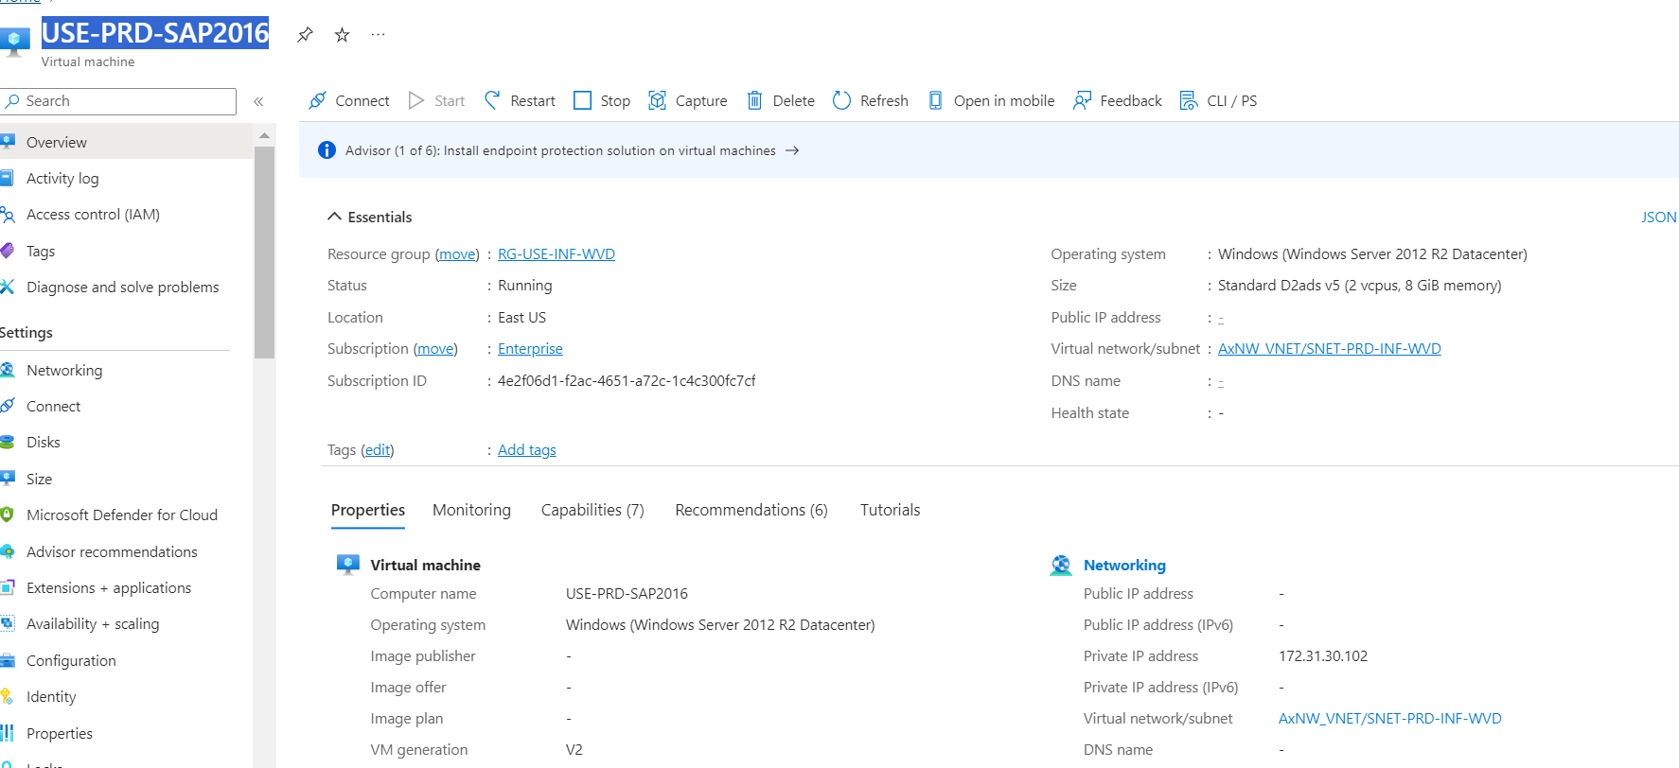

Create a media file from below powershell Script.

Connect-AzAccount

Set-AzContext -SubscriptionId "4e2f06d1-f2ac-4651-a72c-1c4c300fc7cf"

# Customer

# specific parameters

# Resource group of the source VM

$resourceGroup = "Ax_INF_DIR"

# Location of the source VM

$location = "East US"

# Zone of the source VM, if any

#$zone = ""

# Disk name for the that will be created

$diskName = "WindowsServer2016UpgradeDisk"

# Target version for the upgrade - must be either server2022Upgrade or server2019Upgrade

$sku = "server2016Upgrade"

# Common parameters

$publisher = "MicrosoftWindowsServer"

$offer = "WindowsServerUpgrade"

$managedDiskSKU = "Standard_LRS"

#

# Get the latest version of the special (hidden) VM Image from the Azure Marketplace

$versions = Get-AzVMImage -PublisherName $publisher -Location $location -Offer $offer -Skus $sku | sort-object -Descending {[version] $_.Version }

$latestString = $versions[0].Version

# Get the special (hidden) VM Image from the Azure Marketplace by version - the image is used to create a disk to upgrade to the new version

$image = Get-AzVMImage -Location $location `

-PublisherName $publisher `

-Offer $offer `

-Skus $sku `

-Version $latestString

#

# Create Resource Group if it doesn't exist

#

if (-not (Get-AzResourceGroup -Name $resourceGroup -ErrorAction SilentlyContinue)) {

New-AzResourceGroup -Name $resourceGroup -Location $location

}

#

# Create Managed Disk from LUN 0

#

if ($zone){

$diskConfig = New-AzDiskConfig -SkuName $managedDiskSKU `

-CreateOption FromImage `

-Zone $zone `

-Location $location

} else {

$diskConfig = New-AzDiskConfig -SkuName $managedDiskSKU `

-CreateOption FromImage `

-Location $location

}

Set-AzDiskImageReference -Disk $diskConfig -Id $image.Id -Lun 0

New-AzDisk -ResourceGroupName $resourceGroup `

-DiskName $diskName `

-Disk $diskConfig

**Post running below script below disk will be created in the RG**

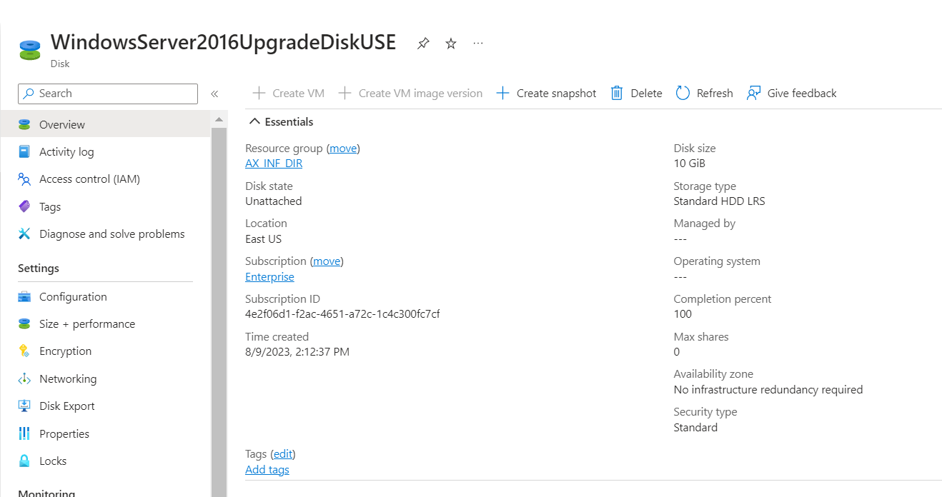

**Attach the disk in the VM**

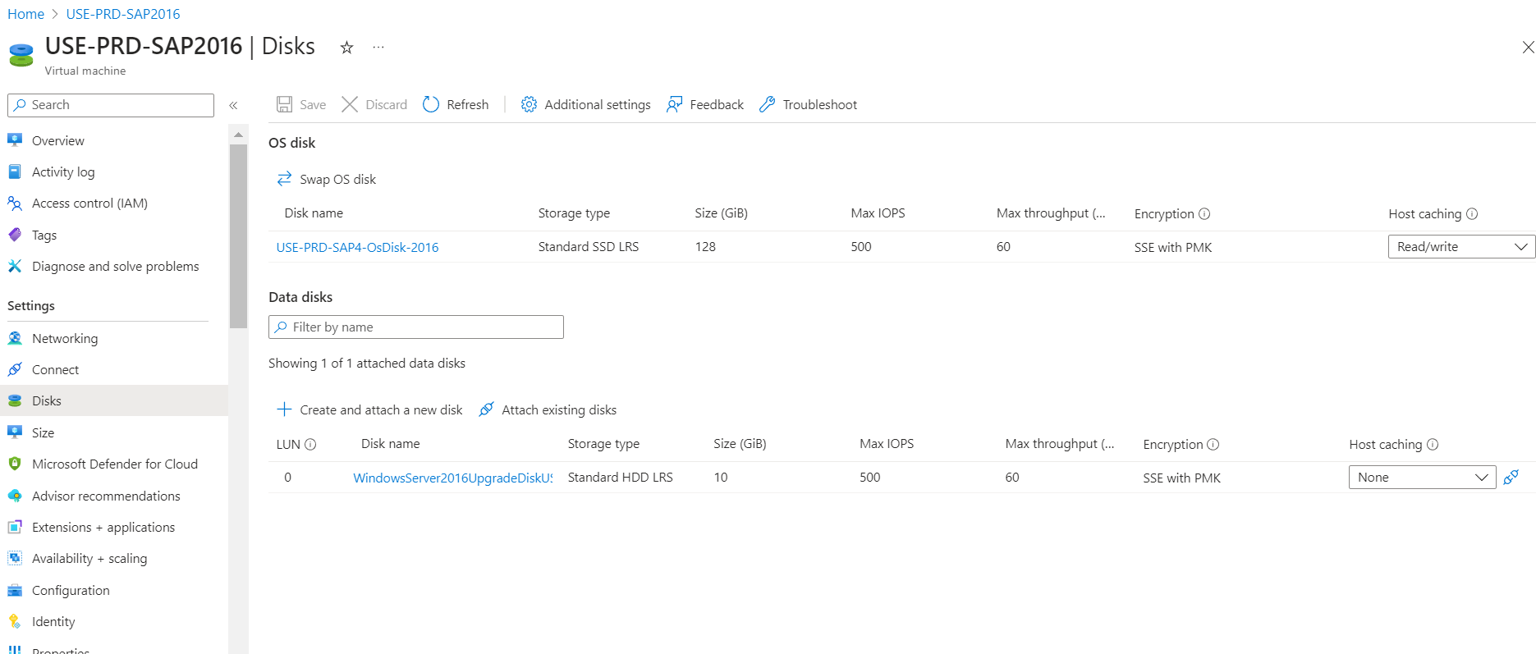

Login the VM using Local credentials you can attached disk will show as E drive

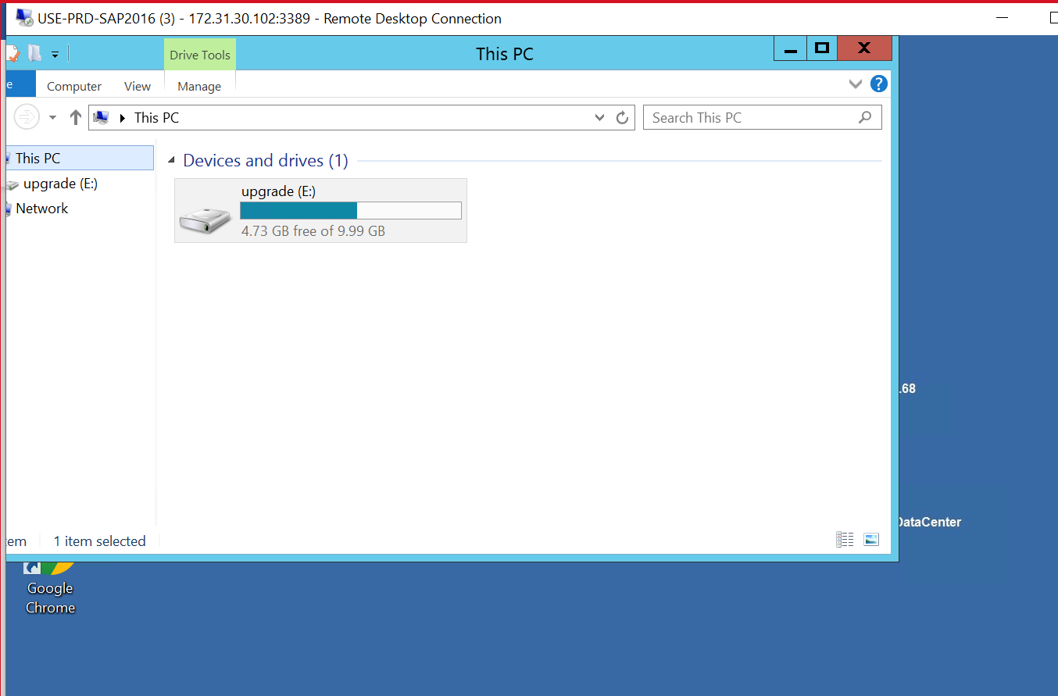

Open Powershell as Administrator and up below Script to Up grade the OS :

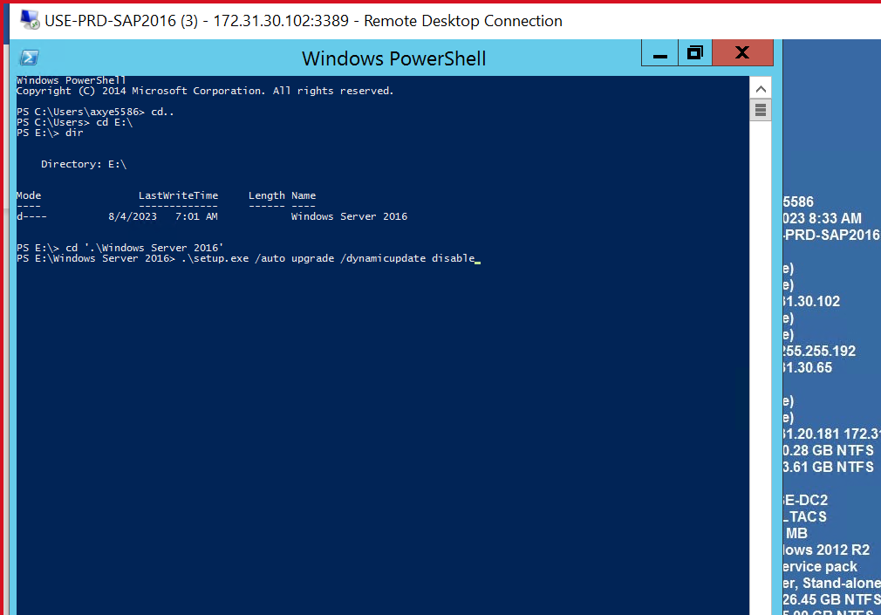

* Execute the following command to start the upgrade:

.\setup.exe /auto upgrade /dynamicupdate disable

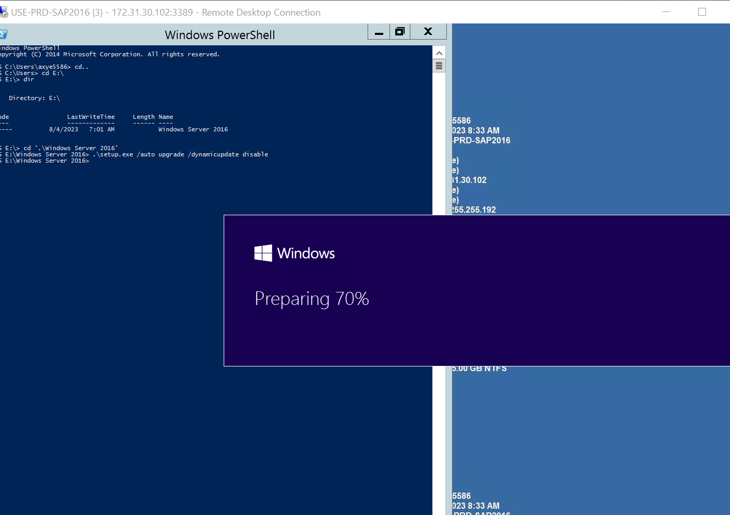

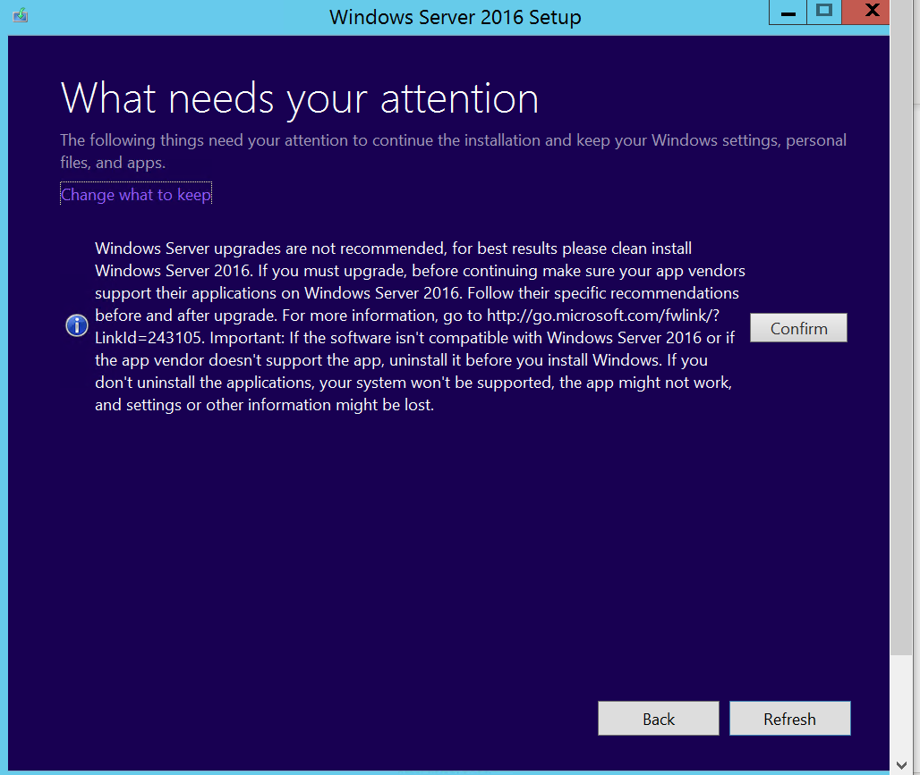

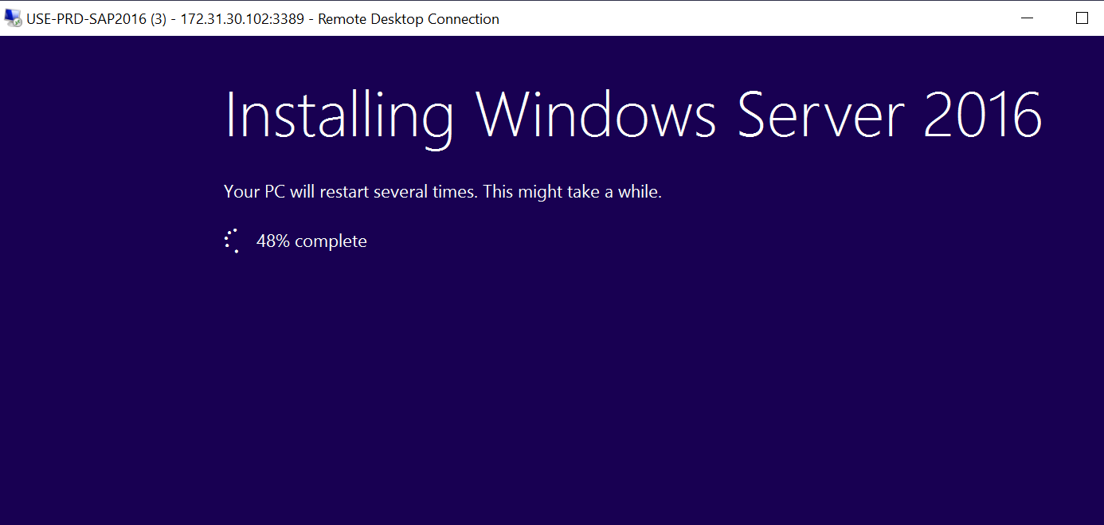

Restart the VM post upgrade finish from OS end post restart check the upgrade statust from boot diagnostic

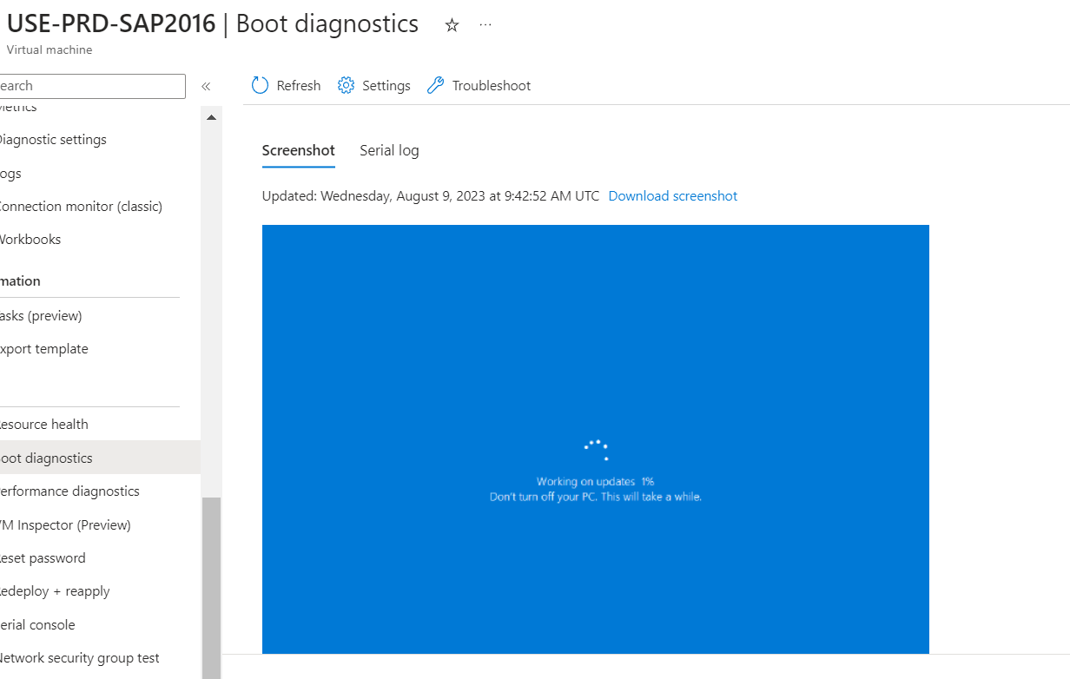

Upgrade is completed

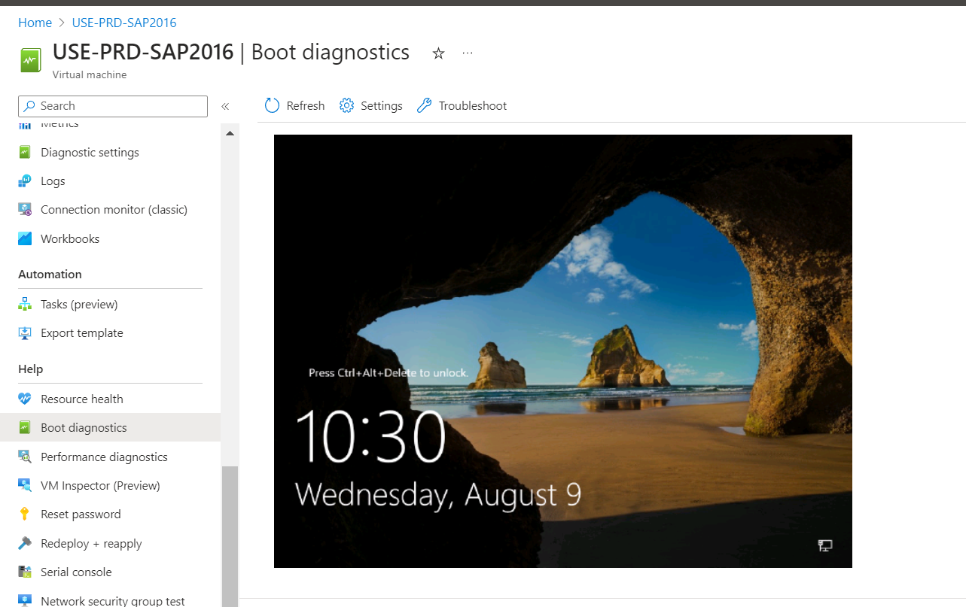

Now the upgraded OS is reflecting in Azure Portal

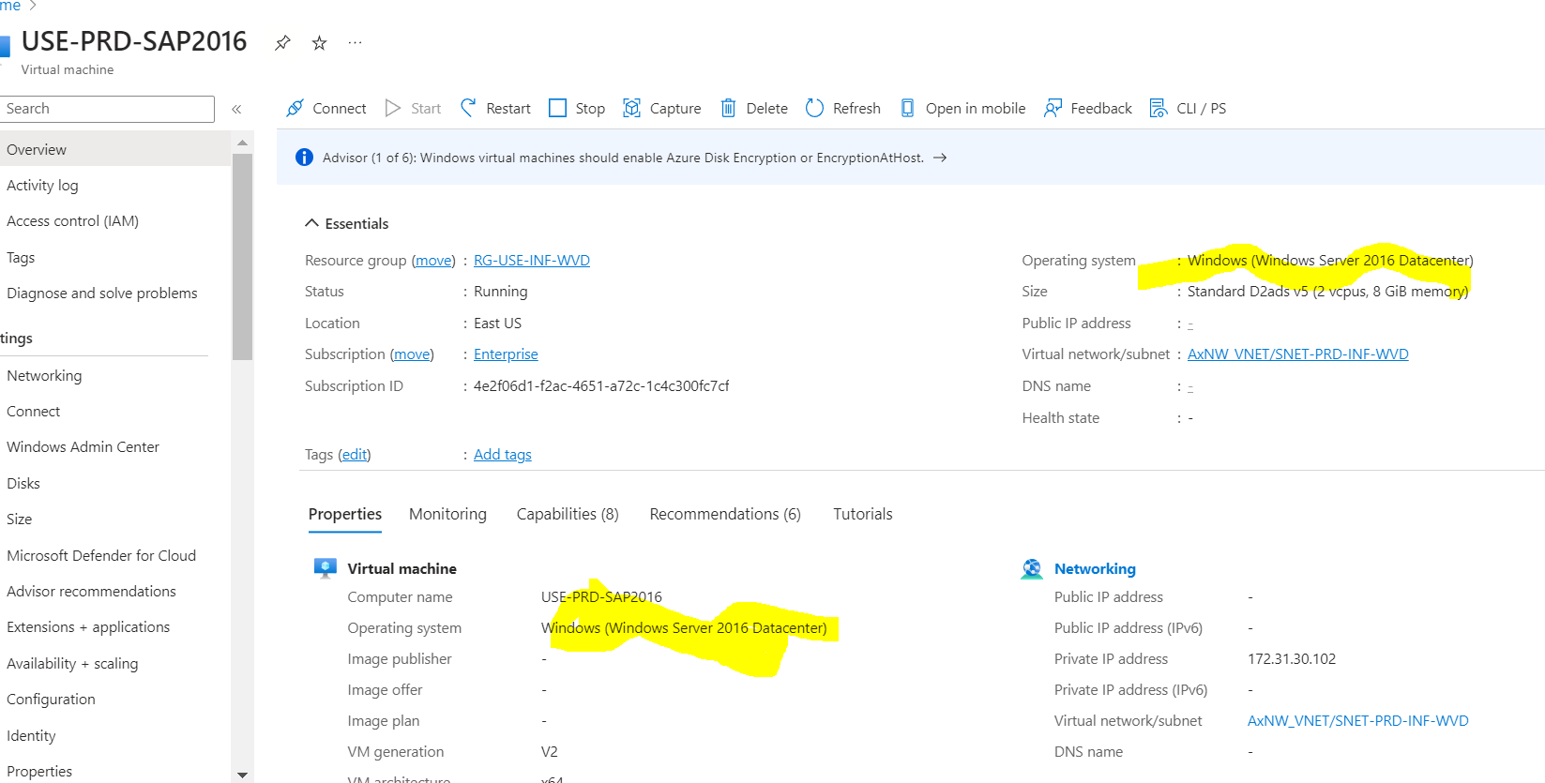

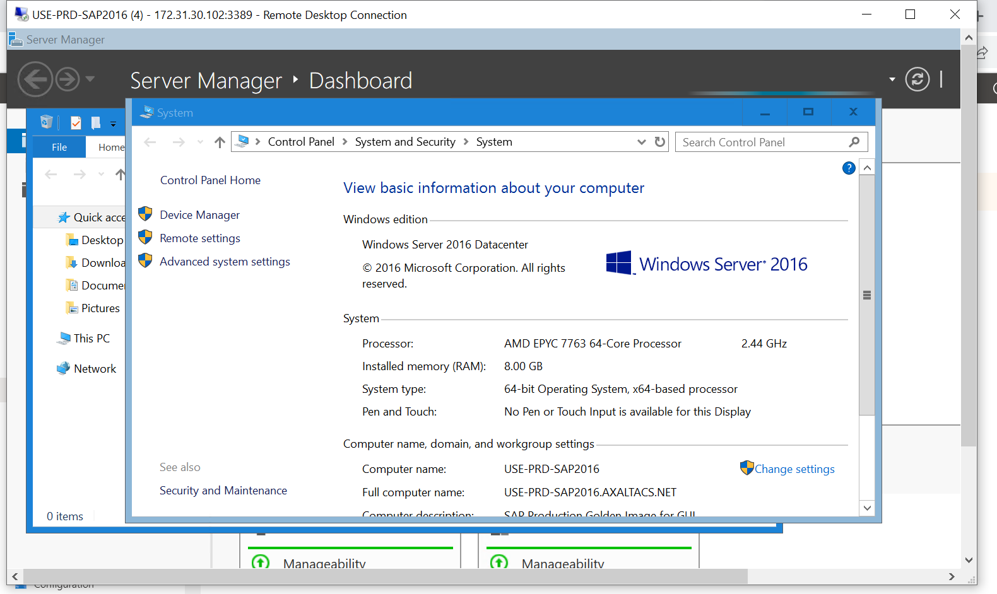

Hence Inplace Upgrade has been performed successfully